One of the parameters for a fuse is I²t, which is a measure of the power the fuse can absorb before it melts and breaks the circuit.

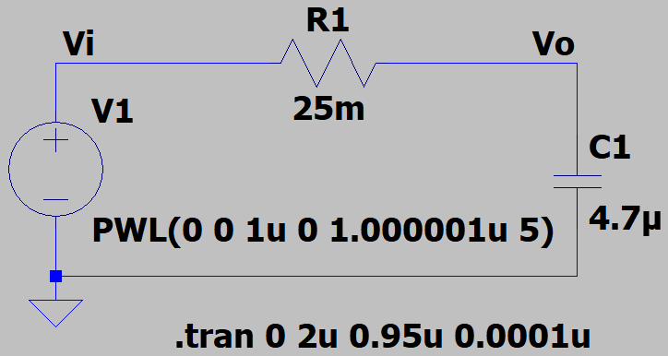

From basic circuit courses we know that, if V1 is suddenly turned on, the voltage across the capacitor will be:

Therefore, the current through the resistor will be:

If the resistor is a fuse, we can find an expression for it’s I²t value:

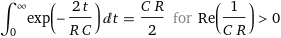

So, for a theoretical case where Vi = 5V, C = 4.7uF and R = 25mΩ: I²t = 2.35E-3

Let’s validate this by running the above simulation in LTspice:
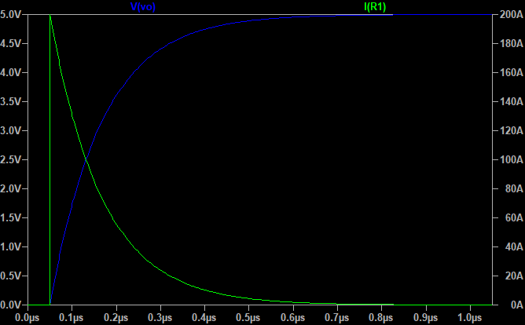

The csv data for I(R1) was exported. It’s value was squared, then imported into Graph:

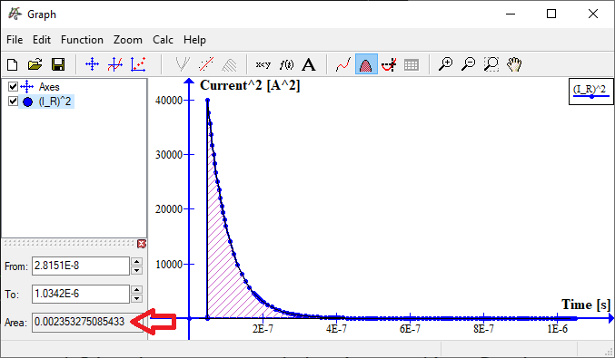

Graph calculated the integral as 2.3533E-3, which agrees with the theoretical value.

spinningnumbers.org/a/rc-step-response.html

